Bus Reservation System

Project Introduction
In today’s world, people prefer quick and easy ways to book their bus tickets instead of standing in long lines at bus stations. Because of this, we decided to create a Bus Reservation System.
This system allows passengers to check available buses, choose their seats, and book tickets online within a few minutes.
Bus operators also benefit because they can manage buses, routes, and schedules without manual work. The system helps keep records of bookings, payments, and cancellations in an organized manner. Overall, this project aims to make bus travel more convenient, fast, and reliable for both passengers and operators.

Users
- Admin
- Passenger
- Guest User

Functionalities

1. Admin
- Login
- Add or delete buses
- Add bus routes
- View all bookings

2. Passenger
- Register or login
- Search buses by source, destination, and date
- Select seats and book tickets
- Cancel booking
- View booking history

3. Guest User (Optional)
- Search buses
- View routes
- Cannot book tickets without registering

Team Members
- Hamad Riyaz (25298008)
- Maryam Ashraf (252980053)
- M. Fahid (252980032)
- Azwah Mahboob (252980001)

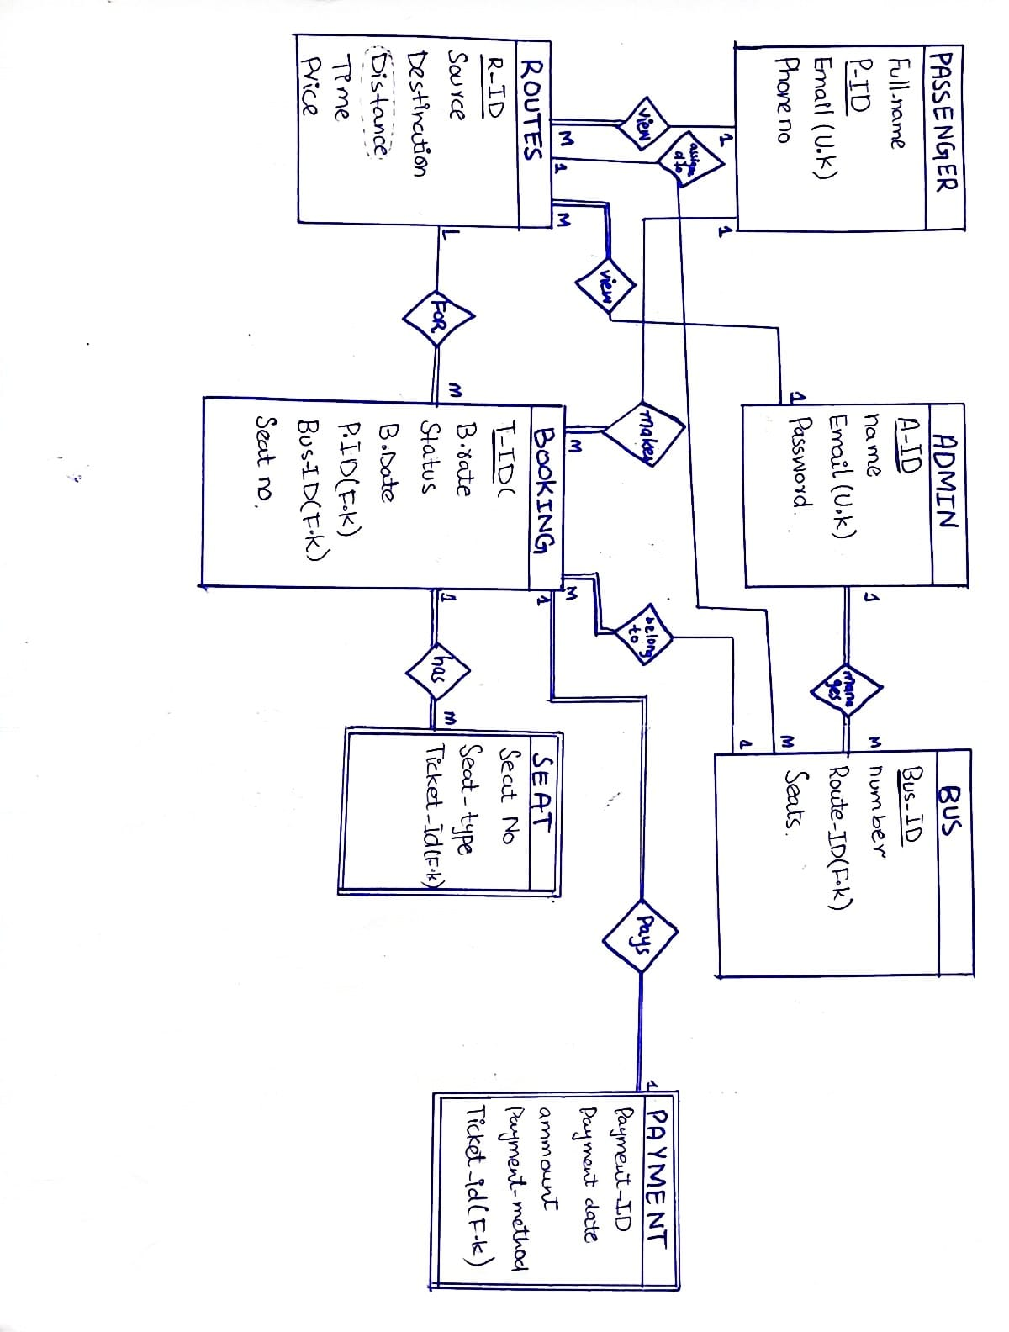
ER Diagram

 | PASSENGER
F-Name | P-ID | EMAIL (UK) | Phone

 | ADMIN
A-ID | Name | Email (Uk) | Password

 |  | BUS
B-ID | Number | Seat | A-Id (FK) | R-ID (FK)

 |  |  | ROUTE
R-id | Source | Des | Time | Price | P-ID (FK) | A-ID (FK)

 |  |  | BOOKING
Ticket-ID | B-rate | Status | B-Date | Seat-No | P-ID (FK) | B-ID (FK) |  | R-ID (FK)

 | SEAT (Weak)
Seat-No | Seat-Type | Ticket-ID  (Unique) (NOTNULL)

 |  | PAYMENT | (Weak)
P-ID | P-Date | Amount | P-Method | Ticket-ID (Unique) (NOTNULL)

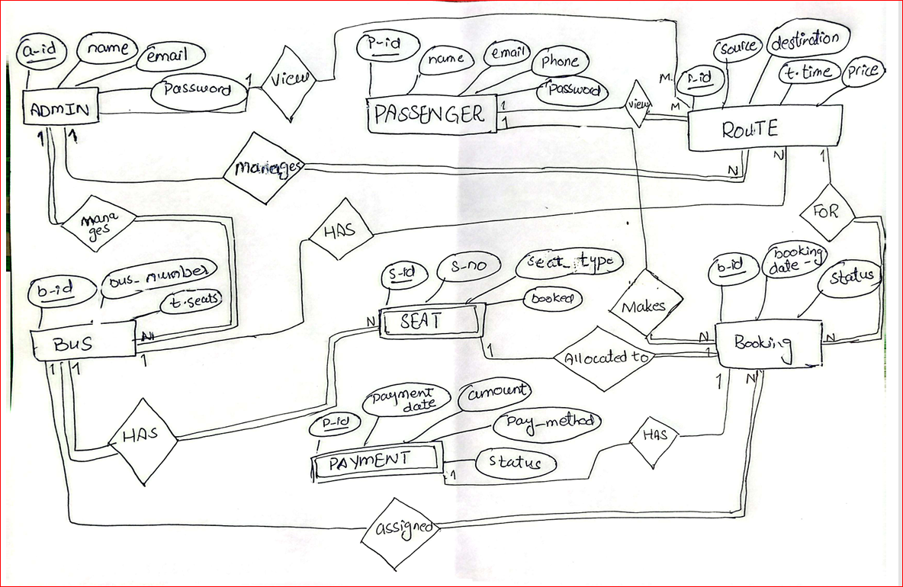

 | PASSENGER
name | P-ID | EMAIL (UK) | Phone | Password

 | ADMIN
A-ID | Name | Email (Uk) | Password

 | BUS
B-ID | Number | A-Id (FK) | R-ID (FK) | Total_seats

 |  |  | ROUTE
R-id | Source | Des | Time | Price | A-ID  (F.K)

 |  |  | BOOKING
Booking-ID | B-rate | Status | B-Date | Seat-id  (FK) | P-ID (FK) | B-ID (FK) |  | R-ID (FK)

 | SEAT (Weak)
Seat_id | Seat-Type | Bus_id  (FK) | Seat_no

 |  | PAYMENT | (Weak)
P-ID | P-Date | Amount | P-Method | Booking-ID  (FK) (Unique) (NOTNULL) | Status

